9/29/2026
Instructor: Sir M. Fahad Qasim
Submitted by: Wasif Ali
Reg id: 245187
Class: BSCS F24 B


HTML
Full-Stack Development Lab
Lab No 03
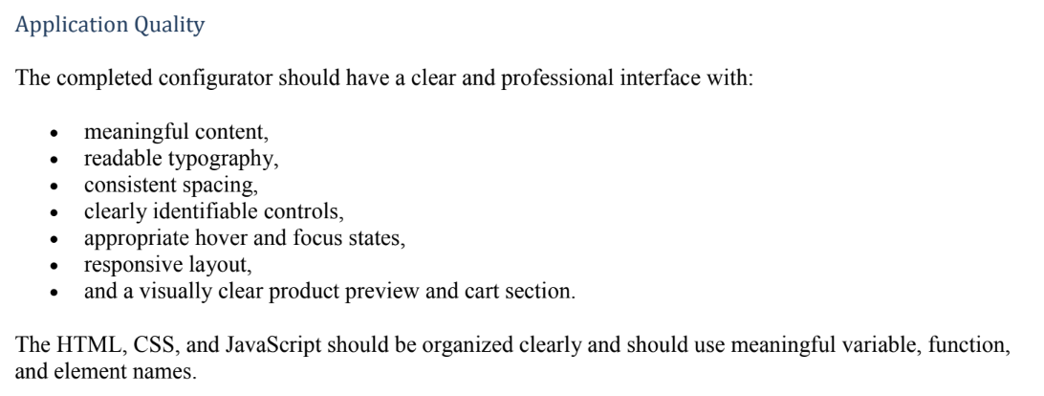
Output:
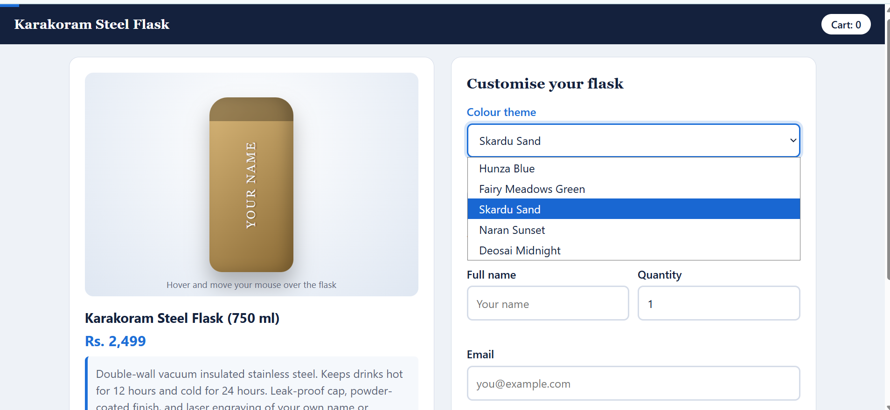
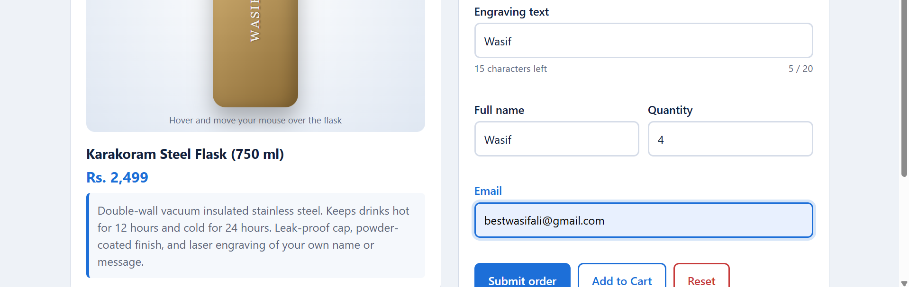
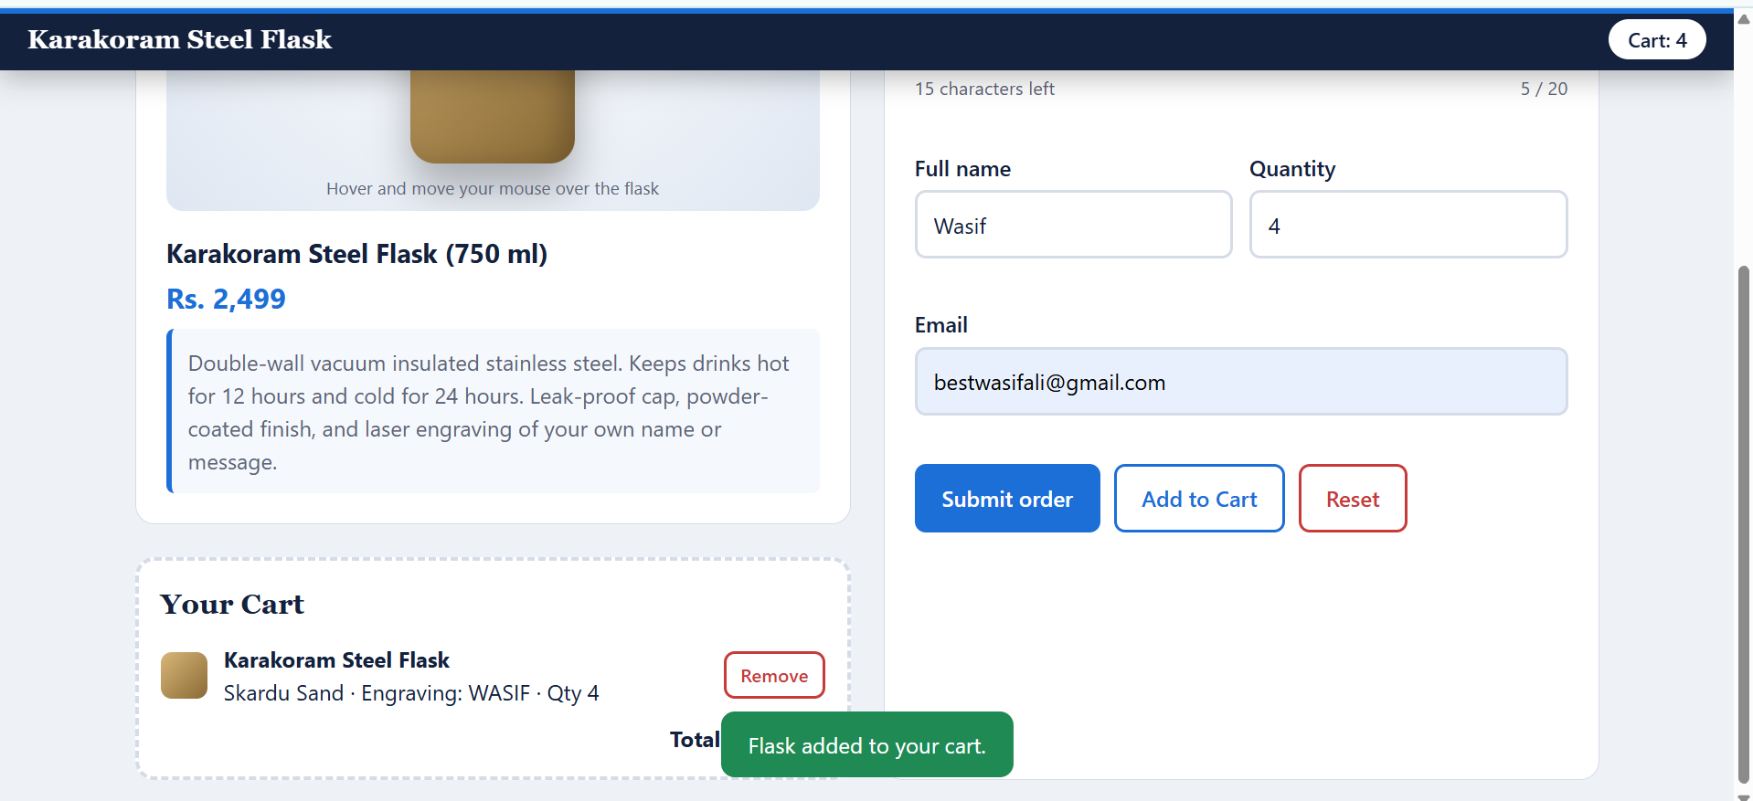

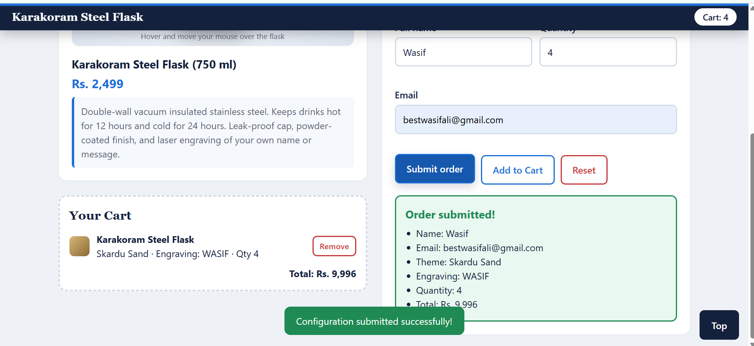

Code:
<!DOCTYPE html>
<html lang="en">

<head>
<meta charset="UTF-8">
<meta name="viewport" content="width=device-width, initial-scale=1">
<title>Karakoram Flask Configurator</title>
<style>
:root {
--ink: #14213d;
--muted: #5b6577;
--bg: #eef2f7;
--card: #ffffff;
--line: #d5dce8;
--accent: #1d6fd8;
--ok: #1f8a54;
--bad: #c73b3b;
--c1: #2b7bd8;
/* flask colour, changed by JS */
--c2: #0d3b7a;
--radius: 14px;
}

* {
box-sizing: border-box;
}

html {
scroll-behavior: smooth;
}

body {
margin: 0;
background: var(--bg);
color: var(--ink);
font-family: "Segoe UI", system-ui, -apple-system, Roboto, Arial, sans-serif;
line-height: 1.5;
}

#scrollBar {
position: fixed;
top: 0;
left: 0;
height: 4px;
width: 0;
background: var(--accent);
z-index: 50;
transition: width .1s;
}

header {
position: sticky;
top: 0;
z-index: 40;
background: var(--ink);
color: #fff;
padding: 14px 20px;
display: flex;
justify-content: space-between;
align-items: center;
gap: 12px;
transition: box-shadow .3s, padding .3s;
}

header.scrolled {
box-shadow: 0 6px 20px rgba(0, 0, 0, .25);
padding: 8px 20px;
}

header h1 {
font-size: 1.15rem;
margin: 0;
font-family: Georgia, "Times New Roman", serif;
letter-spacing: .3px;
}

.cart-badge {
background: #fff;
color: var(--ink);
border-radius: 999px;
padding: 4px 14px;
font-weight: 600;
font-size: .9rem;
transition: transform .25s;
}

.cart-badge.bump {
transform: scale(1.25);
}

main {
max-width: 1100px;
margin: 24px auto;
padding: 0 16px;
display: grid;
grid-template-columns: 1fr 1fr;
gap: 24px;
}

.panel {
background: var(--card);
border: 1px solid var(--line);
border-radius: var(--radius);
padding: 22px;
}

h2 {
margin: 0 0 12px;
font-family: Georgia, serif;
font-size: 1.3rem;
}

/* ---------- Product card (draggable) ---------- */
.product-card {
cursor: grab;
transition: transform .25s, box-shadow .25s, opacity .2s;
}

.product-card.hovered {
box-shadow: 0 14px 34px rgba(20, 33, 61, .18);
transform: translateY(-4px);
border-color: var(--accent);
}

.product-card.dragging {
opacity: .45;
transform: scale(.97);
cursor: grabbing;
}

.stage {
position: relative;
height: 320px;
border-radius: 12px;
overflow: hidden;
background: radial-gradient(circle at 50% 30%, #fff, #dfe7f2);
display: grid;
place-items: center;
perspective: 700px;
}

.flask {
position: relative;
width: 120px;
height: 250px;
border-radius: 26px 26px 18px 18px;
background: linear-gradient(135deg, var(--c1), var(--c2));
box-shadow: 0 18px 30px rgba(0, 0, 0, .28), inset -10px 0 18px rgba(0, 0, 0, .18);
transition: transform .12s ease-out, background .4s;
transform-style: preserve-3d;
overflow: hidden;
}

.flask::before {
/* cap */
content: "";
position: absolute;
top: 0;
left: 0;
right: 0;
height: 34px;
background: rgba(0, 0, 0, .28);
}

.flask::after {
/* glare that follows the pointer */
content: "";
position: absolute;
inset: 0;
background: radial-gradient(circle at var(--mx, 50%) var(--my, 30%), rgba(255, 255, 255, .65), transparent 55%);
opacity: 0;
transition: opacity .3s;
pointer-events: none;
}

.stage.active .flask::after {
opacity: 1;
}

.engraving {
position: absolute;
top: 50%;
left: 50%;
transform: translate(-50%, -50%) rotate(-90deg);
white-space: nowrap;
color: rgba(255, 255, 255, .92);
font-family: Georgia, serif;
font-size: 1.1rem;
letter-spacing: 2px;
text-shadow: 0 1px 2px rgba(0, 0, 0, .5);
pointer-events: none;
}

.stage-hint {
position: absolute;
bottom: 8px;
left: 0;
right: 0;
text-align: center;
font-size: .8rem;
color: var(--muted);
transition: color .3s;
}

.stage.active .stage-hint {
color: var(--accent);
font-weight: 600;
}

.info h3 {
margin: 16px 0 2px;
font-size: 1.2rem;
}

.price {
font-size: 1.3rem;
font-weight: 700;
color: var(--accent);
}

.description {
margin: 8px 0 0;
padding: 12px;
background: #f5f8fc;
border-left: 4px solid var(--accent);
border-radius: 6px;
color: var(--muted);
user-select: none;
-webkit-user-select: none;
transition: background .3s, border-color .3s;
}

.description.blocked {
background: #fdeaea;
border-color: var(--bad);
animation: shake .35s;
}

@keyframes shake {
25% {
transform: translateX(-6px);
}

75% {
transform: translateX(6px);
}
}

/* ---------- Cart / drop zone ---------- */
.dropzone {
margin-top: 24px;
min-height: 150px;
border: 3px dashed var(--line);
border-radius: var(--radius);
padding: 16px;
background: var(--card);
transition: background .25s, border-color .25s, transform .25s;
}

.dropzone.over {
border-color: var(--ok);
background: #e9f8f0;
transform: scale(1.02);
}

.cart-empty {
color: var(--muted);
text-align: center;
padding: 18px 0;
}

.cart-item {
display: flex;
align-items: center;
gap: 12px;
flex-wrap: wrap;
}

.swatch {
width: 34px;
height: 34px;
border-radius: 8px;
flex: none;
}

.cart-item p {
margin: 0;
flex: 1 1 160px;
}

.cart-total {
margin-top: 10px;
font-weight: 700;
text-align: right;
}

/* ---------- Form ---------- */
.field {
margin-bottom: 16px;
}

label {
display: block;
font-weight: 600;
margin-bottom: 5px;
}

input,
select {
width: 100%;
padding: 11px 12px;
font: inherit;
color: var(--ink);
border: 2px solid var(--line);
border-radius: 8px;
background: #fff;
transition: border-color .2s, box-shadow .2s, background .2s;
}

input:hover,
select:hover {
border-color: #a9b6cc;
}

input:focus,
select:focus {
outline: none;
border-color: var(--accent);
box-shadow: 0 0 0 4px rgba(29, 111, 216, .18);
}

.field.is-focused label {
color: var(--accent);
}

.field.invalid input {
border-color: var(--bad);
background: #fff6f6;
}

.hint {
display: flex;
justify-content: space-between;
font-size: .85rem;
color: var(--muted);
margin-top: 4px;
min-height: 1.3em;
}

.hint.warn {
color: var(--bad);
font-weight: 600;
}

.error {
color: var(--bad);
font-size: .85rem;
min-height: 1.2em;
margin-top: 3px;
}

.row {
display: grid;
grid-template-columns: 1fr 1fr;
gap: 12px;
}

.buttons {
display: flex;
gap: 10px;
flex-wrap: wrap;
}

button {
font: inherit;
font-weight: 600;
padding: 11px 18px;
border-radius: 8px;
border: 2px solid var(--accent);
cursor: pointer;
transition: transform .15s, background .2s, color .2s, box-shadow .2s;
}

button:hover {
transform: translateY(-2px);
box-shadow: 0 6px 14px rgba(20, 33, 61, .18);
}

button:active {
transform: translateY(0);
}

button:focus-visible {
outline: 3px solid #ffb703;
outline-offset: 2px;
}

.btn-primary {
background: var(--accent);
color: #fff;
}

.btn-primary:hover {
background: #1558ad;
}

.btn-secondary {
background: #fff;
color: var(--accent);
}

.btn-secondary:hover {
background: #eaf2ff;
}

.btn-danger {
background: #fff;
color: var(--bad);
border-color: var(--bad);
}

.btn-danger:hover {
background: #fdeaea;
}

.btn-small {
padding: 5px 10px;
font-size: .85rem;
}

.result {
margin-top: 18px;
padding: 16px;
border-radius: 10px;
background: #e9f8f0;
border: 2px solid var(--ok);
display: none;
animation: pop .4s;
}

.result.show {
display: block;
}

.result h3 {
margin: 0 0 6px;
color: var(--ok);
}

.result ul {
margin: 0;
padding-left: 18px;
}

@keyframes pop {
from {
transform: scale(.94);
opacity: 0;
}

to {
transform: none;
opacity: 1;
}
}

/* ---------- Toast + back to top ---------- */
#toast {
position: fixed;
left: 50%;
bottom: 24px;
transform: translate(-50%, 100px);
background: var(--ink);
color: #fff;
padding: 12px 20px;
border-radius: 10px;
max-width: 90vw;
text-align: center;
opacity: 0;
transition: transform .35s, opacity .35s;
z-index: 60;
}

#toast.show {
transform: translate(-50%, 0);
opacity: 1;
}

#toast.ok {
background: var(--ok);
}

#toast.bad {
background: var(--bad);
}

#toTop {
position: fixed;
right: 16px;
bottom: 16px;
opacity: 0;
pointer-events: none;
z-index: 45;
background: var(--ink);
color: #fff;
border-color: var(--ink);
}

#toTop.visible {
opacity: 1;
pointer-events: auto;
}

/* ---------- Responsive ---------- */
@media (max-width: 860px) {
main {
grid-template-columns: 1fr;
}
}

@media (max-width: 480px) {
.panel {
padding: 16px;
}

.row {
grid-template-columns: 1fr;
}

.stage {
height: 260px;
}

.flask {
transform-origin: center;
}

.buttons button {
flex: 1 1 100%;
}

#toTop {
bottom: 70px;
}
}

@media (prefers-reduced-motion: reduce) {
* {
transition: none !important;
animation: none !important;
}
}
</style>
</head>

<body>
<div id="scrollBar"></div>

<header id="siteHeader">
<h1>Karakoram Steel Flask</h1>
<span class="cart-badge" id="cartBadge">Cart: 0</span>
</header>

<main>
<!-- LEFT: product + cart -->
<section>
<article class="panel product-card" id="productCard" draggable="true"
aria-label="Product card. Drag it into the cart.">
<div class="stage" id="stage">
<div class="flask" id="flask">
<span class="engraving" id="engravingPreview">YOUR NAME</span>
</div>
<div class="stage-hint" id="stageHint">Hover and move your mouse over the flask</div>
</div>
<div class="info">
<h3>Karakoram Steel Flask (750 ml)</h3>
<div class="price" id="priceLabel">Rs. 2,499</div>
<p class="description" id="description">
Double-wall vacuum insulated stainless steel. Keeps drinks hot for 12 hours and cold for 24
hours.
Leak-proof cap, powder-coated finish, and laser engraving of your own name or message.
</p>
</div>
</article>

<div class="dropzone" id="dropzone" aria-live="polite">
<h2>Your Cart</h2>
<div id="cartContent">
<p class="cart-empty">Cart is empty. Drag the product card here, or use "Add to Cart".</p>
</div>
</div>
</section>

<!-- RIGHT: configurator form -->
<section class="panel">
<h2>Customise your flask</h2>
<form id="configForm" novalidate>
<div class="field">
<label for="variant">Colour theme</label>
<select id="variant" name="variant">
<option value="hunza">Hunza Blue</option>
<option value="fairy">Fairy Meadows Green</option>
<option value="skardu">Skardu Sand</option>
<option value="sunset">Naran Sunset</option>
<option value="night">Deosai Midnight</option>
</select>
</div>

<div class="field">
<label for="engraving">Engraving text</label>
<input type="text" id="engraving" name="engraving" maxlength="20" placeholder="e.g. WASIF"
autocomplete="off">
<div class="hint" id="engravingHint"><span id="engravingMsg">Up to 20 characters</span><span
id="charCount">0 / 20</span></div>
<div class="error" id="engravingError"></div>
</div>

<div class="row">
<div class="field">
<label for="fullName">Full name</label>
<input type="text" id="fullName" name="fullName" placeholder="Your name" autocomplete="name">
<div class="error" id="fullNameError"></div>
</div>
<div class="field">
<label for="quantity">Quantity</label>
<input type="number" id="quantity" name="quantity" min="1" max="10" value="1">
<div class="error" id="quantityError"></div>
</div>
</div>

<div class="field">
<label for="email">Email</label>
<input type="email" id="email" name="email" placeholder="you@example.com" autocomplete="email">
<div class="error" id="emailError"></div>
</div>

<div class="buttons">
<button type="submit" class="btn-primary">Submit order</button>
<button type="button" class="btn-secondary" id="addBtn">Add to Cart</button>
<button type="reset" class="btn-danger">Reset</button>
</div>
</form>

<div class="result" id="result" role="status"></div>
</section>
</main>

<div id="toast" role="status" aria-live="polite"></div>
<button id="toTop" type="button">Top</button>

<script>
/* ============ DATA ============ */
const UNIT_PRICE = 2499;
const VARIANTS = {
hunza: { name: "Hunza Blue", c1: "#2b7bd8", c2: "#0d3b7a" },
fairy: { name: "Fairy Meadows Green", c1: "#3fae6a", c2: "#14532d" },
skardu: { name: "Skardu Sand", c1: "#d9b779", c2: "#8a6a35" },
sunset: { name: "Naran Sunset", c1: "#ff8a4c", c2: "#b3261e" },
night: { name: "Deosai Midnight", c1: "#3a4664", c2: "#0b1020" }
};
let cart = null; // holds the current cart item (or null)
let toastTimer = null;

/* ============ DOM ELEMENTS ============ */
const $ = (id) => document.getElementById(id);
const form = $("configForm"), variantSelect = $("variant"), engravingInput = $("engraving");
const fullNameInput = $("fullName"), quantityInput = $("quantity"), emailInput = $("email");
const stage = $("stage"), flask = $("flask"), engravingPreview = $("engravingPreview"), stageHint = $("stageHint");
const productCard = $("productCard"), description = $("description"), dropzone = $("dropzone");
const cartContent = $("cartContent"), cartBadge = $("cartBadge"), result = $("result");
const charCount = $("charCount"), engravingMsg = $("engravingMsg"), engravingHint = $("engravingHint");
const toast = $("toast"), toTop = $("toTop"), siteHeader = $("siteHeader"), scrollBar = $("scrollBar");

/* ============ HELPERS ============ */
function showToast(message, type = "") {
toast.textContent = message;
toast.className = "show " + type;
clearTimeout(toastTimer);
toastTimer = setTimeout(() => { toast.className = ""; }, 2600);
}
const money = (n) => "Rs. " + n.toLocaleString("en-PK");

function applyVariant() {
const v = VARIANTS[variantSelect.value];
document.documentElement.style.setProperty("--c1", v.c1);
document.documentElement.style.setProperty("--c2", v.c2);
}
function updateEngravingPreview() {
const text = engravingInput.value.trim();
engravingPreview.textContent = text ? text.toUpperCase() : "YOUR NAME";
const len = engravingInput.value.length, max = engravingInput.maxLength;
charCount.textContent = len + " / " + max;
const full = len >= max;
engravingHint.classList.toggle("warn", full);
engravingMsg.textContent = full ? "Character limit reached" : (max - len) + " characters left";
}
function currentConfig() {
return {
variantKey: variantSelect.value,
variant: VARIANTS[variantSelect.value],
engraving: engravingInput.value.trim(),
quantity: Math.max(1, parseInt(quantityInput.value, 10) || 1)
};
}
function renderCart() {
if (!cart) {
cartContent.innerHTML = '<p class="cart-empty">Cart is empty. Drag the product card here, or use "Add to Cart".</p>';
cartBadge.textContent = "Cart: 0";
return;
}
cartContent.innerHTML = `
<div class="cart-item">
<span class="swatch" style="background:linear-gradient(135deg,${cart.variant.c1},${cart.variant.c2})"></span>
<p><strong>Karakoram Steel Flask</strong><br>${cart.variant.name} &middot; Engraving: ${cart.engraving ? cart.engraving.toUpperCase() : "none"} &middot; Qty ${cart.quantity}</p>
<button type="button" class="btn-danger btn-small" id="removeBtn">Remove</button>
</div>
<div class="cart-total">Total: ${money(cart.quantity * UNIT_PRICE)}</div>`;
cartBadge.textContent = "Cart: " + cart.quantity;
cartBadge.classList.add("bump");
setTimeout(() => cartBadge.classList.remove("bump"), 250);
}
function addToCart(source) {
cart = currentConfig();
renderCart();
showToast(source === "drop" ? "Dropped! Flask added to your cart." : "Flask added to your cart.", "ok");
}

/* ============ EVENT 1: change (colour select) ============ */
variantSelect.addEventListener("change", () => {
applyVariant();
showToast("Theme changed to " + VARIANTS[variantSelect.value].name);
});

/* ============ EVENT 2: input (real-time engraving preview) ============ */
engravingInput.addEventListener("input", () => {
updateEngravingPreview();
$("engravingError").textContent = "";
engravingInput.closest(".field").classList.remove("invalid");
});

/* ============ EVENTS 3 + 4: focus / blur on inputs ============ */
form.querySelectorAll("input, select").forEach((el) => {
el.addEventListener("focus", () => el.closest(".field").classList.add("is-focused"));
el.addEventListener("blur", () => {
const field = el.closest(".field");
field.classList.remove("is-focused");
if (el === engravingInput && engravingInput.value.trim() === "") {
engravingMsg.textContent = "Tip: add a name to personalise your flask";
}
});
});

/* ============ EVENTS 5, 6, 7: mousemove / mouseenter / mouseleave ============ */
stage.addEventListener("mouseenter", () => {
stage.classList.add("active");
productCard.classList.add("hovered");
stageHint.textContent = "Nice! Move around to tilt the flask";
});
stage.addEventListener("mousemove", (event) => {
const rect = stage.getBoundingClientRect(); // pointer position relative to the preview
const x = event.clientX - rect.left;
const y = event.clientY - rect.top;
const px = x / rect.width, py = y / rect.height; // 0 to 1
const flaskRect = flask.getBoundingClientRect();
flask.style.setProperty("--mx", ((event.clientX - flaskRect.left) / flaskRect.width * 100) + "%");
flask.style.setProperty("--my", ((event.clientY - flaskRect.top) / flaskRect.height * 100) + "%");
flask.style.transform = `rotateY(${(px - 0.5) * 40}deg) rotateX(${(0.5 - py) * 25}deg)`;
});
stage.addEventListener("mouseleave", () => {
stage.classList.remove("active");
productCard.classList.remove("hovered");
flask.style.transform = "";
stageHint.textContent = "Hover and move your mouse over the flask";
});

/* ============ EVENTS 8, 9: copy / cut are blocked on description ============ */
["copy", "cut"].forEach((type) => {
description.addEventListener(type, (event) => {
event.preventDefault();
description.classList.remove("blocked");
void description.offsetWidth; // restart animation
description.classList.add("blocked");
showToast("Sorry, product description can't be " + (type === "copy" ? "copied." : "cut."), "bad");
setTimeout(() => description.classList.remove("blocked"), 500);
});
});
/* select-all + Ctrl+C also fires "copy" on document, so handle it when the description is involved */
document.addEventListener("copy", (event) => {
const sel = window.getSelection();
if (sel && description.contains(sel.anchorNode)) { event.preventDefault(); showToast("Sorry, product description can't be copied.", "bad"); }
});

/* ============ EVENTS 10-14: drag and drop ============ */
productCard.addEventListener("dragstart", (event) => {
event.dataTransfer.setData("text/plain", "flask-product");
event.dataTransfer.effectAllowed = "copy";
productCard.classList.add("dragging");
});
productCard.addEventListener("dragend", () => productCard.classList.remove("dragging"));
dropzone.addEventListener("dragenter", (event) => { event.preventDefault(); dropzone.classList.add("over"); });
dropzone.addEventListener("dragover", (event) => { event.preventDefault(); event.dataTransfer.dropEffect = "copy"; });
dropzone.addEventListener("dragleave", (event) => {
if (!dropzone.contains(event.relatedTarget)) dropzone.classList.remove("over");
});
dropzone.addEventListener("drop", (event) => {
event.preventDefault();
dropzone.classList.remove("over");
if (event.dataTransfer.getData("text/plain") === "flask-product") addToCart("drop");
});

/* click: Add to Cart button (works on touch screens, where drag is unreliable) and Remove button */
$("addBtn").addEventListener("click", () => addToCart("button"));
cartContent.addEventListener("click", (event) => {
if (event.target.id === "removeBtn") { cart = null; renderCart(); showToast("Item removed from cart."); }
});
quantityInput.addEventListener("change", () => {
if (cart) { cart.quantity = currentConfig().quantity; renderCart(); }
});

/* ============ EVENT 15: submit (validated, no page reload) ============ */
form.addEventListener("submit", (event) => {
event.preventDefault();
const errors = {};
const name = fullNameInput.value.trim(), email = emailInput.value.trim();
const qty = parseInt(quantityInput.value, 10);

if (name.length < 3) errors.fullName = "Please enter your full name (at least 3 letters).";
if (!/^[^\s@]+@[^\s@]+\.[^\s@]+$/.test(email)) errors.email = "Please enter a valid email address.";
if (engravingInput.value.trim() === "") errors.engraving = "Engraving text is required.";
if (!(qty >= 1 && qty <= 10)) errors.quantity = "Quantity must be between 1 and 10.";

["fullName", "email", "engraving", "quantity"].forEach((key) => {
$(key + "Error").textContent = errors[key] || "";
$(key).closest(".field").classList.toggle("invalid", Boolean(errors[key]));
});
if (Object.keys(errors).length) {
result.className = "result";
showToast("Please fix the highlighted fields.", "bad");
form.querySelector(".invalid input").focus();
return;
}
if (!cart) { showToast("Add the flask to your cart first (drag it or use Add to Cart).", "bad"); return; }

cart = currentConfig();
renderCart();
result.innerHTML = `<h3>Order submitted!</h3>
<ul>
<li>Name: ${name}</li>
<li>Email: ${email}</li>
<li>Theme: ${cart.variant.name}</li>
<li>Engraving: ${cart.engraving.toUpperCase()}</li>
<li>Quantity: ${cart.quantity}</li>
<li>Total: ${money(cart.quantity * UNIT_PRICE)}</li>
</ul>`;
result.className = "result show";
result.scrollIntoView({ behavior: "smooth", block: "nearest" });
showToast("Configuration submitted successfully!", "ok");
});

/* ============ EVENT 16: reset ============ */
form.addEventListener("reset", () => {
setTimeout(() => { // wait until the browser clears the inputs
applyVariant();
updateEngravingPreview();
engravingMsg.textContent = "Up to 20 characters";
flask.style.transform = "";
cart = null;
renderCart();
result.className = "result";
form.querySelectorAll(".error").forEach((e) => (e.textContent = ""));
form.querySelectorAll(".field").forEach((f) => f.classList.remove("invalid", "is-focused"));
showToast("Configurator has been reset.");
}, 0);
});

/* ============ EVENT 17: scroll (progress bar, header shadow, back-to-top) ============ */
window.addEventListener("scroll", () => {
const max = document.documentElement.scrollHeight - window.innerHeight;
scrollBar.style.width = (max > 0 ? (window.scrollY / max) * 100 : 0) + "%";
siteHeader.classList.toggle("scrolled", window.scrollY > 20);
toTop.classList.toggle("visible", window.scrollY > 300);
});
toTop.addEventListener("click", () => window.scrollTo({ top: 0, behavior: "smooth" }));

/* ============ INIT ============ */
applyVariant();
updateEngravingPreview();
renderCart();
</script>
</body>

</html>

